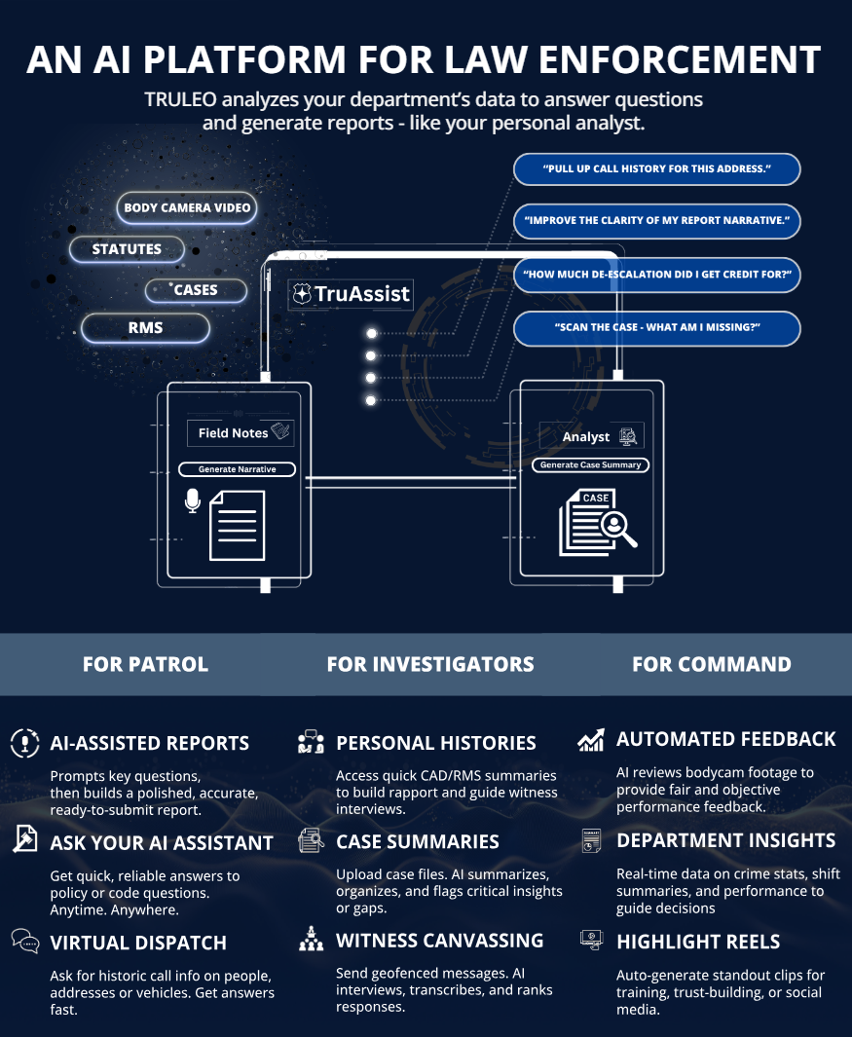

TRULEO AI Assistant Model Policy Guideline

Purpose
The purpose of this document is to establish guidelines for the ethical and effective use of TRULEO’s AI-powered platform, which includes:
- Voice-Generated Reports – AI-enhanced report dictation and transcription.
- Conversational AI for Policy & RMS Queries – AI-powered responses for policy questions, records management system (RMS) data retrieval, and wellness inquiries.
- Body Camera Analytics – Automated transcription, event labeling, summarization, and categorization of body-worn camera (BWC) footage.
This document will assist agencies in compliance with legal standards, promoting professionalism and accountability, and alignment with CALEA accreditation requirements regarding policy robustness, training, supervision, and data utilization.

Training Guidelines

Officer Training Considerations

AI Usage in Report Writing
- Officers will receive initial hands-on training to familiarize themselves with the TRULEO Field Notes and Video Insights tools.
- Training will include practical scenarios demonstrating report dictation, narrative verification, and accuracy assessments.
- Officers will be trained to verify AI-generated narratives and manage AI recommendations effectively.
- Officers will receive instruction regarding the proper copying and pasting of verified content into the RMS system.

Conversational AI for Policy & RMS Queries
- Officers will receive comprehensive training on using Conversational AI to access policy, RMS, and wellness information.
- Training will clarify the limitations and appropriate contexts for AI-generated information.
- Officers will learn verification methods to ensure reliability and accuracy of AI responses.

Body-Worn Camera (BWC) Analytics/Review
- Officers will undergo training on proper use, uploading, and labeling of BWC footage to ensure quality input for AI analytics.
- Training will include how officers can use AI analytics for self-assessment and improvement.
- Officers will be instructed in protocols related to sharing videos with supervisors or training personnel.

General Use of Artificial Intelligence (AI) Technologies
- Officers will participate in comprehensive training regarding ethical, legal, and practical considerations in using AI tools.
- Officers will learn to discern advisory-only outputs from AI and understand the limitations regarding enforcement actions.
- Training will cover identification and reporting of AI errors or biases.

Supervisor Training Considerations

AI Usage in Report Writing
- Supervisors will undergo specialized training on evaluating AI-generated reports for accuracy and completeness.
- Training will cover the process for cross-referencing supplemental reports and conducting periodic audits using Video Insights.
- Supervisors will be trained in recognizing AI-generated errors and ensuring

Conversational AI for Policy & RMS Queries
- Supervisors will receive targeted training on promoting effective use of Conversational AI among officers.
- Supervisors will be trained to use Conversational AI to reinforce officer training and policy comprehension during roll calls or individual development sessions.

Body-Worn Camera (BWC) Analytics/Review
- Supervisors will receive extensive training on conducting periodic video reviews using the TRULEO platform.
- Training will demonstrate the proper documentation of feedback (written, verbal, or via the platform).
- Supervisors will learn to utilize "Praise," "Pending Human Review," and "Nominate a Moment" features for performance management and recognition.

General Use of Artificial Intelligence (AI) Technologies
- Supervisors will receive advanced training in auditing and oversight of AI usage among officers.
- Training will equip supervisors with skills to effectively manage, document, and address improper or biased AI usage.
- Supervisors will be trained to promote transparency and ethical standards in AI applications.

Policy and Procedure Guidelines

Policy 1: AI Usage in Report Writing

Scope
This policy applies to all officers utilizing TRULEO’s AI tools for generating police reports.

Objectives
This policy aims to streamline and enhance the factual accuracy of report-writing processes by leveraging AI-assisted dictation and transcription. It reduces administrative burdens, allowing officers more time for active policing and community engagement.

Definitions
- Voice-Generated Reports: Reports created using AI to transcribe and format an officer’s dictated recollection of events.
- Field Notes: AI-assisted note-taking used to draft initial reports or outlines.
- Video Insights: AI-summarized bullet points of events that occurred within the body-camera transcript of a call for service
- Report Accuracy: Ensuring reports accurately represent events as experienced and recalled by officers.

Officer Responsibilities
- Officers can use Field Notes to capture dictated or typed notes, witness statements, or suspect interviews via the microphone on their agency issued laptop or their mobile phone. Officers are advised to use multiple recording sources in the case that one digital recording fails.
- Officers may utilize Field Notes to voice-generate report narratives for [ AGENCY DECISION: all report types / reports not involving an arrest ]
- To assist with the accuracy and detail of reports, officers may use Video Insights to assist them when completing reports.
- Officers are encouraged to utilize Video Insights to assess the accuracy of their reports and shall never use information generated from this tool as the sole content of the report.
- Once an AI-assisted narrative is generated, officers must verify the accuracy of the content and review and clear any suggestions provided by the AI.
- After completion and in accordance with the procedures above, officers can copy and paste the narrative into the RMS system for review and approval.
- Officers shall not share their generated narratives with other officers as each officer is responsible for documenting their own individual account of the incident.
- [ AGENCY DECISION: Officers must include a disclaimer on their use of AI as per agency policies. ]

Supervisor Responsibilities
- Upon review of reports using AI assistance, Supervisors shall pay special attention to accuracy and completeness.
- If supplemental reports are submitted for the incident, supervisors shall compare the details of each officer to ensure they are congruent with the facts of the incident.
- Periodically, supervisors shall utilize Video Insights to audit the use of Field Notes to ensure adherence to this policy. [ AGENCY DECISION: The frequency and quantity of audits shall be …. ]

Relevant CALEA Standards
41.3.7 (Reports and Records)
82.2.1 (Administrative Reporting)

Policy 2: Conversational AI for Policy & RMS Queries

Scope
This policy applies to all personnel utilizing TRULEO’s Conversational AI for accessing departmental policies, RMS data, or wellness information.

Objectives
This policy aims to provides immediate, anonymous access to policy information and RMS queries via Conversational AI to enhance officers’ decision-making and wellness without compromising data privacy or security.

Definitions
- Conversational AI: TRULEO’s interactive assistant providing policy clarifications, RMS information, and officer wellness resources.
- Anonymous Interaction: Conversations with the AI that are not recorded, stored, or identifiable.
- Limited RMS Queries: Access to basic, non-sensitive RMS data without comprehensive search capabilities.
- Aggregated Audit Data: Data that excludes particular conversational details between an officer and Conversational AI but does include records & policies accessed, the date and time of access, and any AI-generated summaries of records.

Data Privacy Notice
All interactions are 100% anonymous, are not stored, retained, or searchable. No personally identifiable information or conversation transcripts are preserved.

Officer Responsibilities
- Policy & Wellness
- Officers are encouraged to use Conversational AI to ask questions about policy documents, manuals, wellness materials, and guides that the agency has provided TRULEO access to.
- Officers should only use the AI’s responses as supplemental guidance that should not supersede guidance provided directly by a supervisor.
- Officers shall verify all guidance provided before taking action.
- Officers shall not use Conversational AI as a factor in evaluating the use of discretionary actions.
- RMS
- Officers may use Conversational AI to inquire about previous calls for service at an address, arrest and warrant information on an individual, or details about a vehicle based on license plate.
- Officers shall not use Conversational AI to query personal information on individuals unless they are the subject of an active or related investigation.

Supervisor Responsibilities
- Supervisors should encourage the use of Conversational AI and use the tool for the development of employees.
- Supervisors should ensure officers understand policy and procedures related to Conversational AI and its limitations, especially regarding legal or investigatory contexts. [ AGENCY DECISION: Roll call training / case law review can be utilized in the delivery of this training. ]

Relevant CALEA Standards
82.1.6 (Information Technology Security)
33.8.4 (Employee Wellness Programs)

Policy 3: Body-Worn Camera (BWC) Analytics

Scope
This policy applies to personnel utilizing TRULEO’s AI for reviewing, categorizing, and summarizing body-worn camera footage.

Objectives
This policy ensures systematic, unbiased review of body camera footage to detect performance trends, enhance training opportunities, and recognize exemplary officer conduct. Surveillance-oriented use and long-term evidentiary retention beyond the specified limit are expressly prohibited to maintain privacy and ethical standards.

Definitions
- BWC Analytics: Automated transcription, labeling, summarization, and categorization of BWC footage.
- Pending Human Review: AI-flagged BWC videos requiring mandatory supervisory evaluation.
- High Professionalism & High Composure Awards: Automated recognition by AI for exceptional officer conduct.
- Prohibited Surveillance Use: Restriction against global searches and extended data retention periods for surveillance or evidentiary purposes.
- Highlights Folder: AI-flagged BWC videos where the officer used de-escalation techniques, exhibited High Professionalism, and or exhibited High Composure
- Nominate a Moment: Select a portion of a video within TRULEO’s interface that was noteworthy for training and/or recognition.

Prohibited Uses
TRULEO analytics must not be used for surveillance. The platform does not support global searches. Retention of analyzed data is limited strictly to 60 days. All personally identifiable data are automatically redacted and not recoverable.

Officer Responsibilities
- Ensure timely and proper activation of BWC cameras, docking of cameras, and uploading of clearly labeled BWC footage.
- Officers are encouraged to use Truleo to review their own videos for self-assessment and development.
- Officers are encouraged and allowed to share/assign videos with their direct supervisors or the Training Unit for evaluation or feedback.
- [ AGENCY DECISION: Officers shall not share or assign their videos with their peers. ]

Supervisor Responsibilities
- Supervisors shall conduct reviews [ AGENCY DECISION: at least one per week, etc. ] utilizing the Truleo platform.
- Supervisors are required to review [ AGENCY DECISION: provide quantity and type, e.g. all traffic stops that ended in arrest ].
- Supervisors shall document their reviews by providing feedback [ AGENCY DECISION: written, verbal, or through the Truleo platform ] to the employee on their observations.
- Supervisors are strongly encouraged to regularly utilize the “Praise” feature within Truleo to highlight proficiency or positive behaviors and prioritize positive reinforcement in their reviews.
- If training deficiencies or trends are identified during these video reviews, supervisors shall forward/assign these videos to the [ AGENCY DECISION: identify what section of the agency will monitor these needs, e.g. Training Unit.]
- Supervisors should select videos [ AGENCY DECISION: detail quantity ] and create a Moment in the Truleo platform for each officer. These videos should be used as training aids and/or discussion during performance reviews.
- Supervisors should review the “Pending Human Review” and clear all flagged videos of potential use of force and impolite language.
- If any videos require further conversation with an officer or other Supervisor, Supervisors should assign the videos to relevant personnel for further follow up.
- If an agency has other categories of videos they require review on, a Supervisor should view the videos within that category for any relevant follow up actions.

Relevant CALEA Standards
41.3.8 (Body-Worn Cameras)
35.1.9 (Performance Evaluation)
33.1.5 (Training)
84.1.6 (Data Analysis and Evaluation)

Policy 4: General Use of Artificial Intelligence (AI) Technologies

Scope
This policy applies to all personnel utilizing Artificial Intelligence (AI) technologies within the Department, including but not limited to AI tools provided by TRULEO, as well as any third-party AI applications authorized by the Department.

Objectives
This policy ensures the ethical, legal, and transparent use of AI to enhance officer efficiency, safety, decision-making, and wellness, while safeguarding civil liberties and maintaining public trust.

Definitions
- Artificial Intelligence (AI): Software systems that simulate human reasoning to interpret data, provide recommendations, or assist with decision-making.
- Body-Worn Camera (BWC) Analytics: AI-driven review and categorization of BWC footage.
- Computer-Aided Dispatch (CAD) and Records Management System (RMS): Platforms supporting call logging, dispatch, and incident documentation.
- Personally Identifiable Information (PII): Information capable of identifying or tracing a specific individual.
- Wellness AI Assistant: An anonymized AI tool officers can use for confidential mental health and wellness support.

Officer Responsibilities
- Officers must treat AI outputs as advisory only. Human judgment remains the sole basis for legal or enforcement decisions.
- Officers may use AI tools for permissible purposes such as summarizing training materials, drafting reports, reviewing BWC footage, and accessing wellness resources.
- Officers must not use AI to independently initiate detentions, arrests, or legal actions, or justify their use of force.
- Officers must not use AI for surveillance or profiling based on race, ethnicity, socioeconomic status, or geography.
- Officers shall immediately report any observed bias, error, or malfunction in AI systems to a supervisor.

Supervisor Responsibilities
- Supervisors must ensure officers are trained on appropriate and lawful AI use.
- Supervisors should audit AI usage periodically to confirm compliance.
- Supervisors must address improper use of AI and document concerns.
- Supervisors shall promote understanding of AI capabilities and limitations.

Relevant CALEA Standards
82.1.6 (Information Technology Security)
41.3.7 (Reports and Records)
33.8.4 (Employee Wellness Programs)
1.2.9 (Bias-Based Policing)

Policy 4 Addendum: AI Governance and Oversight

Scope
This Addendum applies to Department leadership, procurement teams, IT management, legal advisors, and any personnel responsible for the acquisition, deployment, governance, or oversight of AI technologies.

Objectives
This policy ensures transparent, ethical, and legally compliant deployment of AI systems by establishing governance structures, procurement safeguards, and public accountability measures.

Definitions
- AI Oversight Committee: A multidisciplinary group responsible for reviewing AI system procurement, performance, audits, and complaints.
- Public AI Registry: A public-facing inventory of deployed AI systems, including purposes, data practices, and community safeguards.
- Emergency Exception: A temporary deviation from this policy authorized by the Chief of Police under urgent circumstances.

Permissible Uses of AI
The following AI applications are authorized under this policy:
- Body-Worn Camera (BWC) Analysis for Performance Management
- Summarizing Legal Content for Training
- AI-Assisted Report Writing (with Dictation Requirement)
- In-Vehicle CAD/RMS Summarization
- Administrative and Operational Support
- Crime Pattern Analysis and Resource Planning
- Wellness Support Conversations
- License Plate Recognition (LPR)

Prohibited Uses of AI
The Department prohibits the following uses of AI:
- Automating detentions, arrests, use of force, or legal decision-making.
- Facial recognition without judicial authorization or exigent circumstances.
- Passive monitoring of community behavior through BWC or AI sensors.
- Report generation using BWC data alone, without officer dictation or articulation.
- AI trained on biased or ethically questionable datasets.
- Surveillance or profiling based on race, ethnicity, socioeconomic status, or geography.

Agency Responsibilities
Procurement Standards
- Prohibited Vendors – The Department will not procure AI from:
  - Defense contractors or weapons manufacturers.
  - Vendors who will not disclose system architecture or training data.
  - Entities unable to meet transparency, audit, and privacy standards.
- Vendor Obligations – All vendors must:
  - Disclose training data, bias testing, and system logic.
  - Allow independent audits.
  - Ensure data security and retention policies comply with law.
Privacy, Bias, and Accountability Standards
- Privacy Safeguards
  - AI systems will minimize and anonymize all data where possible.
  - Personally identifiable information may only be used when legally authorized and with strict access controls.
  - No data from wellness AI tools will be shared, analyzed, or saved.
- Anti-Bias Protocols
  - Every AI application will undergo pre-deployment and quarterly audits for racial, gender, and geographic bias.
- Officer Oversight
  - AI outputs must never override or replace human judgment. Officers are always accountable for actions based on AI assistance.
Transparency and Public Trust Standards
- AI Oversight Committee
  - A multidisciplinary committee—including IT, legal, internal affairs, training, and community engagement—will oversee AI use and address concerns.
- Public AI Registry
  - The Department will publish a public-facing registry identifying:
    - AI systems in use
    - Purpose and scope
    - Data practices
    - Community safeguards
- Annual Audit and Report
  - The Department will publish an AI Annual Report.
Emergency Exemptions
Temporary, emergency exceptions to this policy may be approved in writing by the Chief of Police. Each exception must be documented, justified, and reviewed within 30 days by the AI Oversight Committee.

Relevant CALEA Standards
1.2.9 (Bias-Based Policing)
82.1.6 (Information Technology Security)
11.4.1 (Policy Review and Revision)

