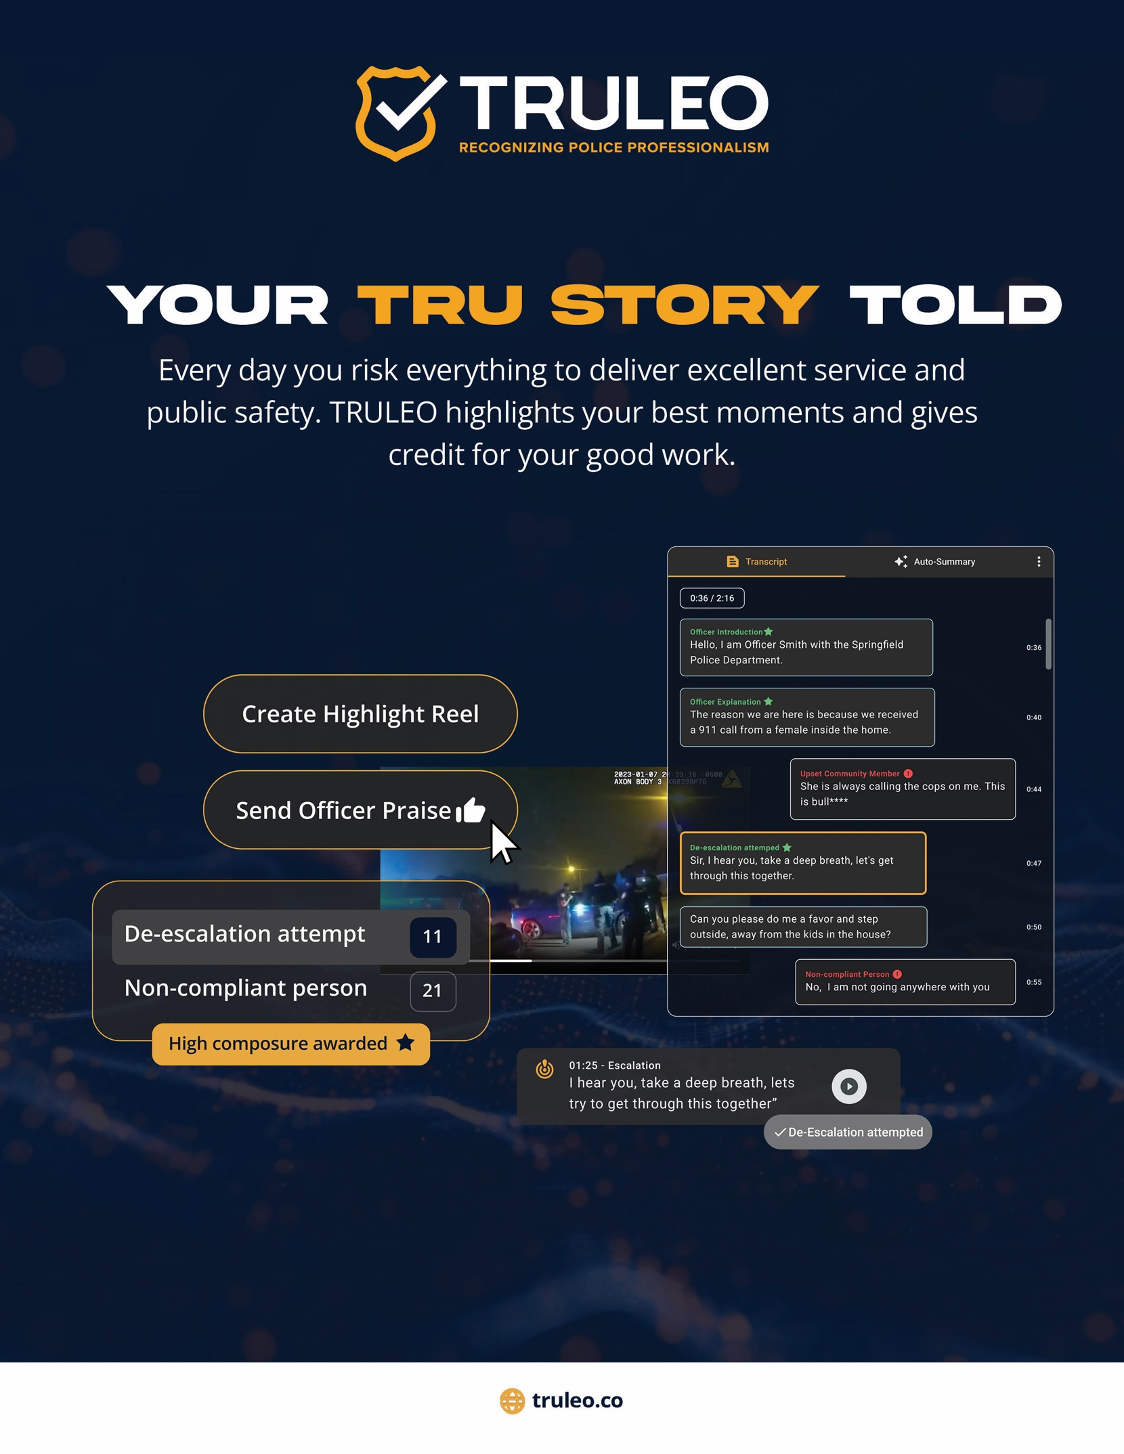

TRULEO END USER LICENSE AGREEMENT
This TRULEO End User License Agreement (this “Agreement”) is by and between TRULEO, Inc., a Delaware corporation (“TRULEO”), and the entity identified on the signature page (“Department”), on the date signed below. TRULEO and Department may be referred to herein collectively as the “Parties” or individually as a “Party.”
The Parties agree as follows:
1. Definitions. The term “Authorized User” means an employee or contractor of the Department who the Department permits to access and use the Platform according to the Department’s license hereunder. The term “Platform” means FBI CJIS cloud servers and patented body camera audio transcription and analytics software described in Appendix A.
2. License. The Term of this Agreement is outlined in Appendix B
(a) License Grant. During the Term, and subject to and conditioned on the Department’s payment of Fees and compliance with all other terms and conditions of this Agreement, TRULEO grants the Department a non-exclusive, non-sublicensable, and non-transferable license during the Term to: (i) access and use the Platform solely for Department’s internal training purposes and personnel performance management. THE PLATFORM IS LICENSED TO THE DEPARTMENT, NOT SOLD.
(b) Use Restrictions. The department shall not use the Platform for any purposes beyond the scope of the license granted in this Agreement or for any purpose that infringes, misappropriates, or otherwise violates any intellectual property right or other right of any person or that violates any applicable law. PERONALLY IDENTIFIABLE DATA IS REDACTED AND THERE IS NO ABILITY TO PERFORM GLOBAL SEARCHES SO THE PLATFORM CAN NOT BE USED AS AN INVESTIGATIVE OR SURVEILLANCE TOOL.
(c) Delivery Process and Obligations. The Department shall, on or before the start of the Term, deliver API keys to TRULEO to access the Department’s body-worn camera video storage environment. Such access shall be continuous during the Term. TRULEO shall host the Platform on FBI CJIS compliant AWS Gov Cloud infrastructure. TRULEO shall then connect the Department’s video storage environment to the Platform. TRULEO shall deliver admin access credentials to the Department to access the secure cloud Platform such that the Department is the only entity that can access the Platform. The Platform shall be deemed to have been accepted by the Department thirty (30) days after the start of the Term unless before such date The Department has provided TRULEO written notice containing reasonable details of non-conformity. TRULEO EMPLOYEES DO NOT HAVE ACCESS TO THE DEPARTMENT’S VIDEOS.
(d) . Maintenance and Support This Agreement entitles the Department to maintenance and support described in Appendix C.
3. Department Responsibilities.
(a) General. Department is responsible and liable for all uses of the Platform resulting from access provided by the Department, directly or indirectly, whether such access or use is permitted by or in violation of this Agreement.
(b) Access to Body Camera Video Storage. The Department is solely responsible for providing access to the body camera video storage environment. The Department acknowledges the videos do not belong to the body camera provider and the department will instruct the body camera video storage provider to fully cooperate with TRULEO to gain access to the department’s videos. THE DEPARTMENT’S FAILURE OR INABILITY TO PROVIDE BODY CAMERA VIDEOS TO TRULEO SHALL NOT AFFECT THE DEPARTMENT OBLIGATIONS TO FULFILL ALL OBLIGATIONS UNDER THIS AGREEMENT, INCLUDING WITHOUT LIMITATION PAYMENT OF ALL FEES AND OTHER AMOUNTS DUE.

4. Fees, Payment. The department shall pay TRULEO the fees (“Fees”) outlined in Appendix B on or before the due date. If Department fails to make any payment when due, in addition to all other remedies that may be available: (i) TRULEO may charge the Department a late fee of $500 per day until full payment is received, (ii) Department shall reimburse TRULEO for all reasonable costs incurred by TRULEO in collecting any late payments, late fees or interest, including attorneys’ fees, court costs, and collection agency fees; and (iii) if such failure continues for thirty (30) days, TRULEO may (i) suspend or prohibit access to the Platform and/or (ii) terminate this Agreement by written notice. All Fees and other amounts payable by the Department under this Agreement are exclusive of taxes. ALL FEES PAID ARE NON-REFUNDABLE.
5. Term and Termination.
(a) Term. The term and the renewal term(s) of this Agreement are outlined in Appendix B (the “Term”) unless terminated earlier according to any of the Agreement’s express provisions.
(b) Termination. Either Party may terminate this Agreement by written notice if the other Party materially breaches this Agreement and the breaching Party fails to cure the breach within sixty (60) days after the non-breaching Party provides written notice of such breach.
(c) Effect of Expiration of Termination. Upon expiration or earlier termination of this Agreement, the license granted hereunder will also terminate. NO EXPIRATION OR TERMINATION WILL AFFECT THE DEPARTMENT’S OBLIGATION TO PAY ALL FEES OR ENTITLE THE DEPARTMENT TO ANY REFUND.
6. Intellectual Property Ownership; Feedback.
(a) The Department acknowledges that TRULEO has a patented platform and owns all rights, titles, and interests, including all intellectual property rights and technology, in and to the Platform.
(b) If the Department or any of its employees or contractors sends or transmits any communications or materials to TRULEO by mail, email, telephone, or otherwise, suggesting or recommending changes to the Platform., including without limitation, new features or functionality relating or any comments, questions, suggestions, or the like (“Feedback”), TRULEO is free to use such Feedback without any attribution or compensation to any party, any ideas, know-how, concepts, techniques, or other intellectual property rights contained in the Feedback.
7. Quality Assurance; Insurance
(a) The department acknowledges that the primary function of the Platform is to analyze officer language within body-worn camera audio to accurately label events occurring between officers and community members. In conjunction with the Department’s goals, the TRULEO Quality Assurance team may review any label weights, outputs, and/or transcript error corrections within the Platform to determine the source of inaccuracies, such as poor audio quality recording or muted segments, to improve the overall accuracy of the offering.
(b) During the Term, TRULEO shall secure and maintain the insurance coverages set forth on Appendix E.
8. Limited Warranties; Warranty Disclaimer.
(a) TRULEO warrants that the Platform will perform materially as described during the Term. TRULEO strictly disclaims all warranties to any Third-Party Products. If TRULEO fails to repair or replace the Platform within ninety (90) days following the Department’s notice of breach of warranty, the Department may terminate the Agreement by written notice. These are the Department’s sole remedies and TRULEO’s sole liability under the limited warranty.
(b) EXCEPT FOR THE LIMITED WARRANTY SET FORTH ABOVE, THE SOFTWARE IS PROVIDED “AS IS” AND TRULEO MAKES NO WARRANTY OF ANY KIND.
9. Limitations of Liability. IN NO EVENT WILL TRULEO’S AGGREGATE LIABILITY ARISING OUT OF OR RELATED TO THIS AGREEMENT EXCEED $5,000.
10. Appendices. The terms and conditions set forth on each Appendix attached to this Agreement are incorporated as if set forth fully herein. In the event of a conflict between the express terms of this Agreement and any Appendix, the Appendix shall prevail.
11. Miscellaneous.
(a) Entire Agreement. This Agreement, together with any other documents incorporated herein by reference and each attached Appendix, constitutes the sole and entire agreement of the Parties to the subject matter of this Agreement and supersedes all prior and contemporaneous understandings, agreements, and representations and warranties, both written and oral, to such subject matter.
(b) Force Majeure. In no event shall TRULEO be liable to the Department, or be deemed to have breached this Agreement, for any failure or delay in performing its obligations under this Agreement, if and to the extent such failure or delay is caused by any circumstances beyond TRULEO’s reasonable control, including but not limited to acts of God, flood, fire, earthquake, explosion, war, terrorism, invasion, riot or other civil unrest, strikes, labor stoppages or slowdowns or other industrial disturbances, or passage of law or any action taken by a governmental or public authority, including imposing a stay-at-home or similar order.
(c) Amendment and Modification; Waiver. No amendment to or modification of this Agreement is effective unless it is in writing and signed by an authorized representative of each Party.
(d) Governing Law This Agreement is governed by and construed under the laws of the State of Illinois.
(e) Enforcement Costs. In the event a Party is forced to initiate legal action, commence litigation and/or other dispute resolution process to enforce its rights under this Agreement against the other Party, the non-prevailing Party shall reimburse the prevailing Party for its fees and costs incurred related to such activities, including but not limited to reasonable attorneys’ fees and court costs.
(f) Assignment. The department may not assign or transfer any of its rights or delegate any of its obligations hereunder, in each case whether voluntarily, involuntarily, by operation of law, or otherwise, without the prior written consent of TRULEO.
(g) Compliance with Laws. Each Party warrants that it will comply with all applicable national, state, and local laws, ordinances, rules, and regulations applicable to each Party in its performance under this Agreement.
(h) Power and Authority. Each Party represents and warrants that (A) it has full power and authority to enter into and perform this Agreement and that the execution and delivery of this Agreement has been duly authorized; and (B) this Agreement and such Party’s performance hereunder will not breach any other agreement to which the Party is a party or is bound or violate any obligation owed by such Party to any third-party.
(i) Publicity. Department agrees that TRULEO may communicate on its website, to a third party, advertise, or publicly announce via a press release that it is providing, or has provided, products or services to the Department.
(j) Signatures; Counterparts. This Agreement may be executed in counterparts and/or via electronic signatures, each of which is deemed an original, but all of which together is deemed to be the same agreement. A true copy of this Agreement delivered by e-mail or other means of electronic transmission shall be deemed an original for all purposes.
SIGNATURE PAGE

IN WITNESS WHEREOF, each Party, by and through its respective authorized representative, has duly executed and delivered this Agreement on the date below.

DEPARTMENT

By:/s/____________________________
Name:
ITS:
Dated: ___________________________
Email:

"Departments that provide their officers with an AI-powered assistant are the gold standard in law enforcement. They are committed to reducing administrative burden for their officers while maintaining a professional and effective culture through unbiased, objective, continuous training, feedback, and positive reinforcement.

Anthony Tassone TRULEO Co-Founder & CEO
Board Member FBI National Academy Associates Fndn.

TRULEO

By:/s/____________________________
Name: Anthony Tassone
ITS: CEO
Dated: ___________________________
Email: at@truleo.co

Appendix A – Problem and Solution

Problem
Many law enforcement agencies in the U.S. review less than 1% of their body camera videos due to limited resources, making positive reinforcement difficult and exacerbating nationwide officer morale, recruiting, and retention challenges. Some departments deploy a “random review” process, but that process is filled with supervisor bias and fails to provide training value and a holistic view of an officer’s performance. In addition, simple transcription and keyword searches exposes officer and civilian personally identifiable data which creates privacy concerns and leaving 99% of the department’s videos unreviewed represents a major liability to the city and a missed opportunity to improve police operations, training outcomes, and community relations.

Evidence-based Solution
TRULEO is an AI-powered assistant that an officer speaks with to generate reports, increase knowledge of policy and laws, and provide automated coaching and recognition. TRULEO is the most ethical, unbiased, and evidence-based AI assistant in policing, proven to increase positive outcomes for officers and the communities they serve. TRULEO is proudly 100% made in America, open-sourced, and is incorporated into the curriculum at the FBI National Academy in Quantico, Virginia.
TRULEO is an objective, unbiased, independent 3rd party audit software that will improve officer performance, wellness, and morale. TRULEO does not sell weapons, body cameras or body camera video storage solutions. TRULEO makes 100% review fast and efficient, removing supervisor bias, and recognizing officers that display high levels of professionalism. Random control trial studies have demonstrated that BOTH the community and officer have better outcomes with TRULEO than without.

Why 100% Made in America Matters: TRULEO’s Commitment to Our National Security
Artificial intelligence is the most powerful capability humanity has ever created. Providing this technology to U.S. police departments requires a 100% made-in-America commitment to law enforcement agencies and the U.S. taxpayers that fund them. Our policy of 100% made-in-America reflects our dedication to supporting the American workforce and ensuring critical technologies remain within our borders. TRULEO is proud to create jobs that support American workers and their families. TRULEO will never outsource or offshore the development of our software, because we want to provide our clients with the confidence and reassurance that their sensitive information is safe and secure. By ensuring that our technology is developed exclusively within the United States, TRULEO upholds the highest standards of security and sovereignty.

FBI CJIS Compliant Cloud (AWS Gov Cloud)
TRULEO provides an Application Programming Interface (API) for automated BWC analytics from the Department BWC database. This API simplifies the process of data retrieval and eliminates the need for duplication of data. All transactions by TRULEO are logged in the BWC database and visible in the audit log. With this API, TRULEO’s AI engine will automatically transcribe BWC audio and label events as configured by the Department during onboarding. Department-authorized users will access the analytics via TRULEO’s web application.

PRICING

 |  |  | AI-POWERED POLICE ASSISTANT
TIER |  |  | VOICE |  | RECORDS |  | VIDEOS
MONTHLY PRICING |  |  | FREE |  | $20 PER OFFICER |  | $30 PER OFFICER
INTEGRATION |  |  | NONE REQUIRED |  | RECORDS MANAGEMENT |  | BWC LIBRARY
FEATURES |  |  | Conversational AI |  | Conversational AI |  | Virtual FTO
 |  |  | Voice Generate Reports |  | Voice-Generated Queries & Summary |  | 100% BWC Review
 |  |  | Ask Policy Questions |  | License Plate Look Up |  | Positive Reinforcement
 |  |  | Policy Change Podcasts |  | Incident Summaries |  | Timelines and Summaries
 |  |  | Ask Penal Code and Statues |  | POI Summaries |  | Training Reels
 |  |  |  |  |  |  | Officer Wellness Logs
 |  |  | * TRULEO does not charge for U.S. Veterans
 |  |  | **AI-Powered video redaction can be purchased for $1 per hour of BWC video
 |  |  | *** RECORDS & VIDEOS can be bundled together for $45 per officer per month

Appendix B –Terms & Fees

TERMS & FEES
Contract Duration | 12 Months
Term Start Date | January 30th, 2025
Licenses | 20 Officers X $45 X 12 Months = $10,800
US VETERAN DISCOUNT | 3 Officers X $45 X 12 Months = ($1620)
Total Annual Amount | $9,180
Payment Terms | Net 30

Automatic Renewal. Upon the expiration of the original term, this agreement shall be automatically renewed for an additional three (3) year period unless, at least ninety (90) days prior to the expiration, either party gives the other party written notice of its intent not to continue the agreement. During any renewal term this agreement, the terms as set forth herein shall remain in effect unless modified in writing.

Appendix C – Maintenance and Support

1. MAINTENANCE AND SUPPORT SERVICES
TRULEO shall provide the following maintenance and support services inclusive of the Fees paid, including any bug fixes, patches, updates, and revisions. During the Term, TRULEO will also provide the Department with any updates to the Documentation.
TRULEO maintenance and support contact information is as follows:
Address: 119 W 24th St, New York, NY 10011
Phone: (888) 991-3897
Email: support@TRULEO.co
2. SCOPE OF SUPPORT
Any defects shall be reported using the details below and any escalation necessary shall follow the escalation procedure set forth hereinafter. Reported defects may be classified by the Department as “Fatal”, “Material” or “Standard”.
TRULEO will provide assistance, help, and support, plus resolution of defects, via the following channels: Telephone Support
TRULEO shall maintain telephone support with "live" staff as a single point of contact to provide help with Department operation and support of the cloud services, the cloud application, or the Platform. TRULEO will immediately upon taking a telephone call reporting a defect, record full details of the defect in its issue tracking database and issue a tracking number to the Department. If the telephone support is unavailable, TRULEO will allow the Department to leave a message.
Remote Diagnostic Support
If requested by Department, TRULEO will provide remote diagnostic support as appropriate to resolve any defect.
Monitored Email Support
TRULEO will monitor incoming emails received at support@TRULEO.co reporting a defect, record full details of the defect in its issue tracking database, and issue a tracking number to the Department. TRULEO will respond within 24 business hours.
3. SUPPORT HOURS
Hours of Support
TRULEO shall provide telephone, remote, and email support 8 hours per day, each business day of the year excluding public holidays.
For any support request received during out-of-office hours, action will take place the next open business day.
09:00 to 17:00 EDT hours Monday to Friday

Appendix D –Main Contacts

 | Main Contacts
Name |  |  |  | Company Title |  | Email |  | Cell phone
Anthony Tassone |  |  |  | Co-founder & CEO |  | AT@truleo.co
Tejas Shastry |  |  |  | Co-founder & CTO |  | Tejas@truleo.co
PJ Tassone |  |  |  | Success Manger |  | PJ@Truleo.co

Appendix E – Insurance

TRULEO shall secure, prior to commencing any activities under this Agreement, and maintain, during the term of this Agreement, insurance coverage commensurate with applicable law as follows:
Workers’ Compensation Insurance and Employers Liability Insurance in an amount not less than $1,000,000.
Commercial General Liability Insurance, including coverage for Premises and Operations, Contractual Liability, Personal Injury Liability, Products/Completed Operations Liability, and Independent Contractor’s Liability (if applicable), in an amount not less than $4,000,000 annual aggregate, written on an on an occurrence form.
Automobile Liability Coverage including-as applicable-owned, non-owned, and hired autos, in an amount not less than $1,000,000, combined single limit.
Professional Liability Insurance, inclusive of cyber liability, in an amount not less than $2,000,000.

