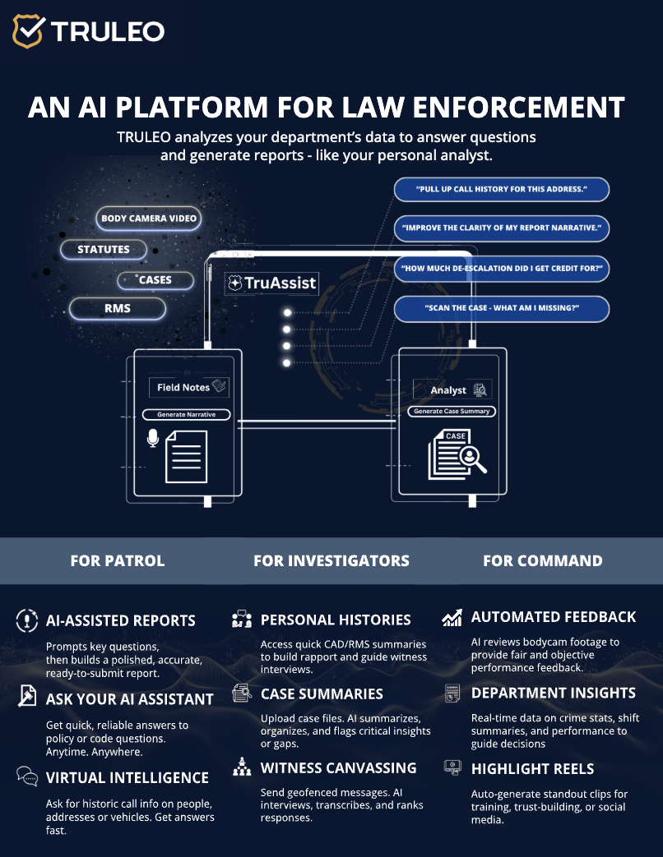

TRULEO SOLE SOURCE LETTER

Truleo is the sole provider of Patented AI- powered police officer assistant. Truleo’s software (US patent allowance: https://patentcenter.uspto.gov /applications /18180652) is the only technology that:
- Automatically SEPARATES Officer language from Community language. TRULEO automatically detects and separates the officer’s language which makes for more accurate report writing and transcripts.
- Automatically REDACTS Officer and Community member personal identifiable information (PII). This data is critical to protect and avoid sending to 3rd party AI engines that otherwise could retain it and / or use it for training as well as leaving the data vulnerable to being stolen by U.S. adversaries.

Problem
Law enforcement agencies across the country are facing severe staffing shortages, which directly impact officer morale, retention, and crime clearance rates. Patrol officers, Investigators and Command staff are stretched thin, overwhelmed by administrative tasks, lack access to critical insights that can improve performance. Without real-time automation and insights, both officer safety and clearance rates are at risk.
Evidence-based Solution
TRULEO is the only Patented AI-powered platform designed to support officers, detectives and command:
a) Assisting in drafting report narratives, witness statements and administrative reports
b) Answer questions about policies, laws, and prior incidents
c) Deliver automated coaching, recognition and redaction from BWC videos
d) Generate investigative case summaries and insights to solve more crime
TRULEO is the most ethical, unbiased, and evidence-based AI assistant available to law enforcement. Multiple independent studies have proven it to reduce administrative workload, enhance officer training, and improve retention. Proudly developed in the United States, TRULEO integrated into the FBI National Academy curriculum in Quantico, Virginia.
Conflict-Free Government Purchasing
TRULEO does not manufacture or sell weapons because doing so would undermine the neutrality and integrity of its AI technology. It is critical to maintain a clear separation between AI providers and weapons manufacturers to preserve public trust, avoid ethical conflicts, and ensure that technology used to enhance officer performance and accountability remains free from profit-driven influence tied to the use of force.
100% Made in America Matters: TRULEO’s Commitment to National Security
Artificial intelligence represents one of the most powerful tools ever developed. TRULEO’s 100% Made-in-America policy reflects our unwavering commitment to safeguarding national security, supporting the American workforce, and keeping critical technologies under U.S. control. This approach provides peace of mind to the law enforcement agencies we serve and to the American taxpayers who fund them. Unlike our competitors, we will never offshore the research and /or development of any capability.

